**Advanced Networking Assignment**

**(CISCO Packet Tracer)**

Semester 2

Paper: Advanced Networking Laboratory

Subject: Computer Application

Course: MCA (2 years)

**University of Calcutta**



|  |  |  |
| --- | --- | --- |
| **Name** | **Registration No.** | **Roll Number** |
| Swarnadeep Das | A03-1112-0175-20 | C91/MCA/232032 |

**Assignment 1: Making a Connection on Router & End Devices**

1. Take one router
2. Take two PC’s (end devices)
3. Connect router and end devices with copper cross wires
4. Configure IP address of each device as shown in the figure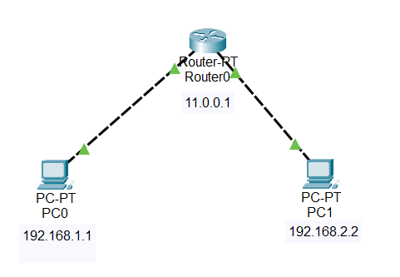
5. Test Connectivity with ping command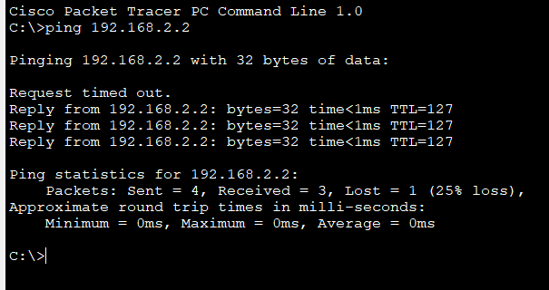

**Assignment 2: Making a Connection with Static Routing Across 4 Routers**

1. Add four routers
2. Take 2 end devices for each of the routers
3. Connect the router’s serial ports using serial DCE or DTE cables
4. Take 4 switches for each of the networks
5. Connect them all with copper straight wire
6. Configure IP addresses shown in the figure

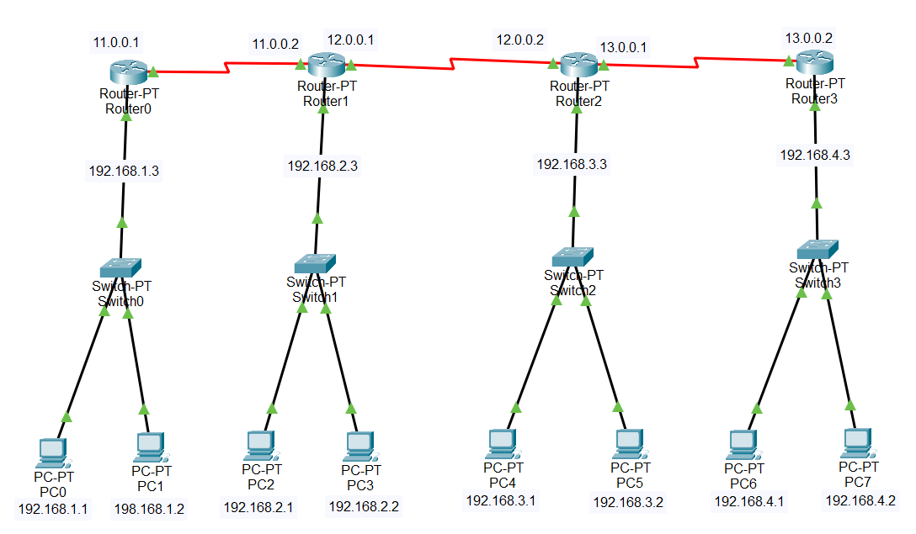

1. Add Network Addresses, subnet mask and next hop addresses to the static routing table of the routers

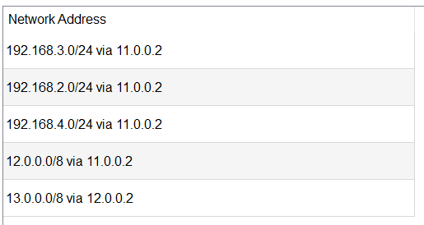

1. Check connection by using ping command

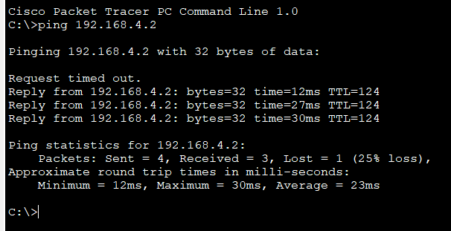

**Assignment 3: Making a Connection Using Dynamic Routing**

1. Add 3 routers
2. Connect the serial ports of them using wire
3. Add 3 switches for each router
4. Add 2 end devices for each switch
5. Connect them with copper wire and assign IP address to them like the given picture

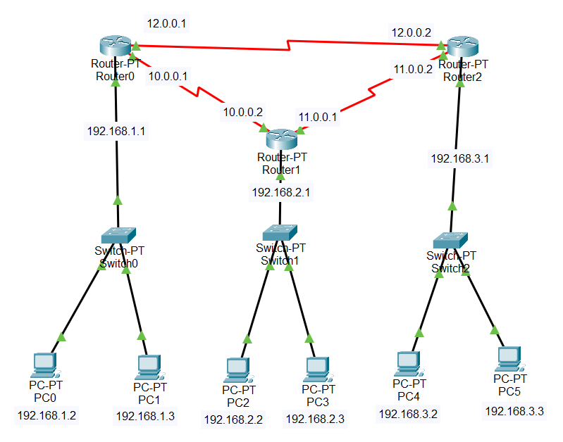

1. Add RIP protocol to each of the router
2. As a dynamic routing protocol it does not need any next hop addresses

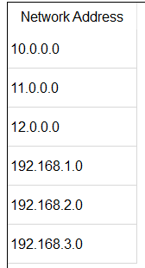

1. Check the connection using ping command

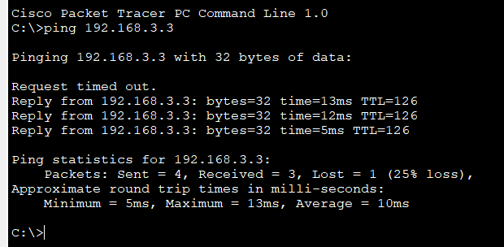

**Assignment 4: Configuring Basic Router Settings and Setting Password with IOS CLI**

**Step 1: Access the CLI of a Router**

1. Connect to the router via console cable, SSH, or telnet
2. Open a terminal emulator

**Step 2: Configure Basic Settings**

1. **Enter Global Configuration Mode:**

Router> enable

Router# configure terminal

Router(config)#

1. **Set the Hostname:**

Router(config)# hostname MyRouter

MyRouter(config)#

1. **Set the Domain Name:**

MyRouter(config)# ip domain-name mydomain.com

MyRouter(config)#

1. **Configure Interface IP Addresses:**

MyRouter(config)# interface GigabitEthernet0/0

MyRouter(config-if)# ip address 192.168.1.1 255.255.255.0

MyRouter(config-if)# no shutdown

MyRouter(config-if)# exit

Repeat for other interfaces as needed.

**Step 3: Set an Enable Secret Password**

1. **Enter Global Configuration Mode (if not already):**

MyRouter(config)# enable secret mySecretPassword

**Step 4: Set Console and VTY Line Passwords**

1. **Set Console Line Password:**

MyRouter(config)# line console 0

MyRouter(config-line)# password consolePassword

MyRouter(config-line)# login

MyRouter(config-line)# exit

1. **Set VTY Line Passwords:**

MyRouter(config)# line vty 0 4

MyRouter(config-line)# password vtyPassword

MyRouter(config-line)# login

MyRouter(config-line)# exit

**Step 5: Save the Configuration**

1. **Exit to Privileged EXEC Mode:**

MyRouter(config)# end

MyRouter#

1. **Save the Configuration to NVRAM:**

MyRouter# write memory

**Assignment 5: Configuring Static Routing with 3 Routers Using CLI Commands**

**Steps**

1. Connecting End Devices:

a. We take 8 different end devices and 4 switches.

b. We connect the end devices to the switches using copper

straight-through wires.

c. We use copper straight-through wires to connect the switches to the

routers.

2. Configuring Routers:

a. Since more ports are needed for the routers, we click on the router and

go to Physical -> WIC-2T.

b. We turn off the router, drag the WIC-2T module inside the router's box,

and turn it back on.

c. Now we connect the routers using Serial DTE cables.

3. Assigning IP Addresses:

a. We assign IP addresses to the end devices.

b. We set the default gateway of each end device to the corresponding

router's IP address.

4. Enabling Router Interfaces:

We click the router and then go to CLI and then do the following :

a. We enable the first router by writing ‘en’

b. Then after the hash sign comes we write ‘conf t’ to configure our switch

port.

c. We configure the Ethernet port using ‘int fa 0/0’. Now we add the IP

address and the mask by the following command ‘ip add 192.168.10.1

255.255.255.0’

d. We write ‘no shutdown’ to turn the state from down to up. Next, we write ‘ex’ to exit.

e. We configure other ports in the same way. (For serial port we write ‘int

serial 0/0/0’)

f. We repeat the above steps for all the other routers

5. Defining Network Routes:

a. To enable communication between networks, we define the routes.

b. Now we give the network, mask, and next hop by the command

‘ip route 192.168.11.0 255.255.255.0 11.0.0.2’

Following these steps will enable the end devices to communicate with each other,

establishing a functional network connection.

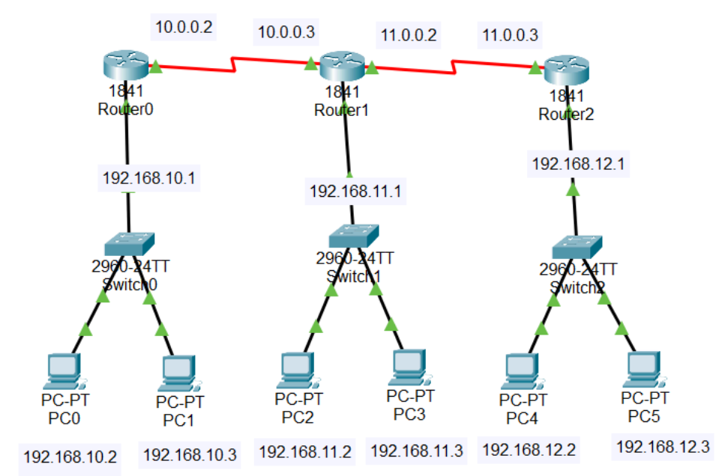

**Assignment 6: Create Bus, Ring, Star, Mesh and Hybrid Topology**

* 1. Bus Topology:

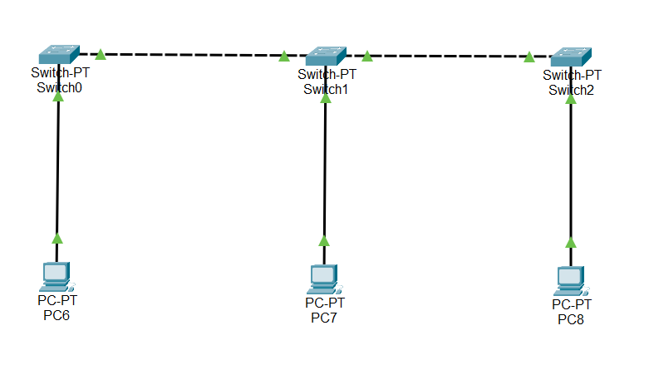

* 1. Ring Topology: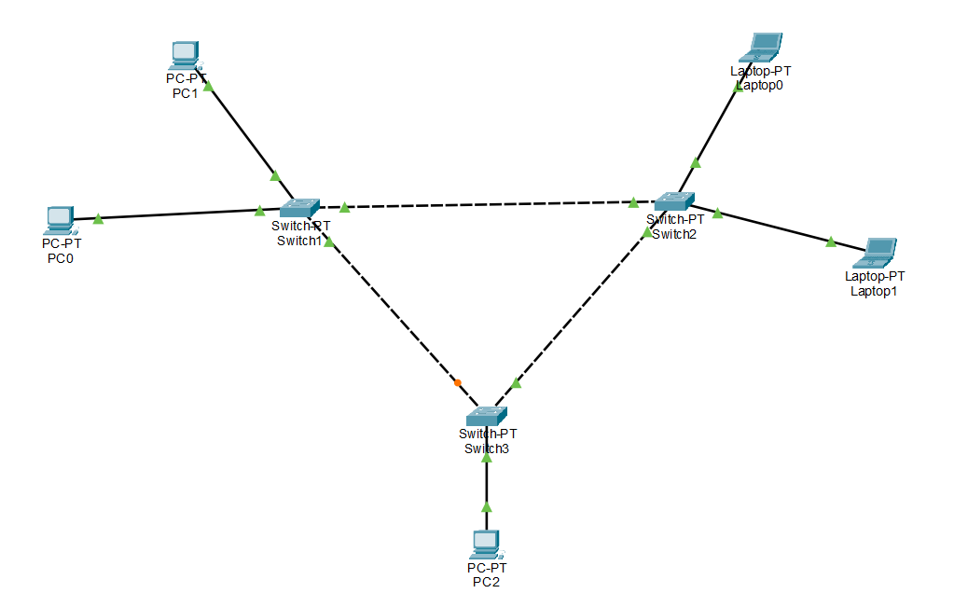

1. Star Topology:

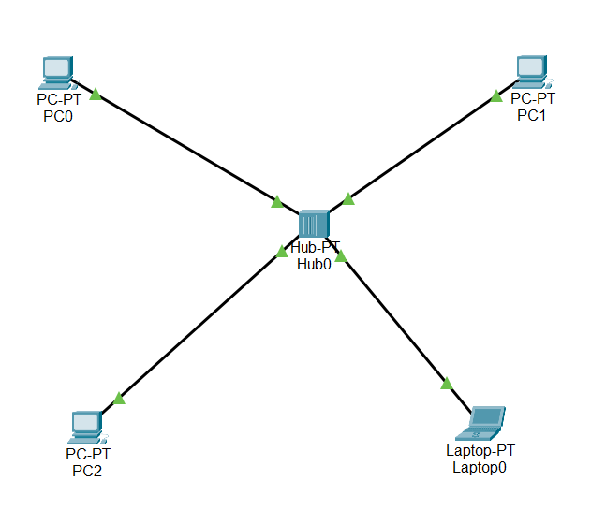

1. 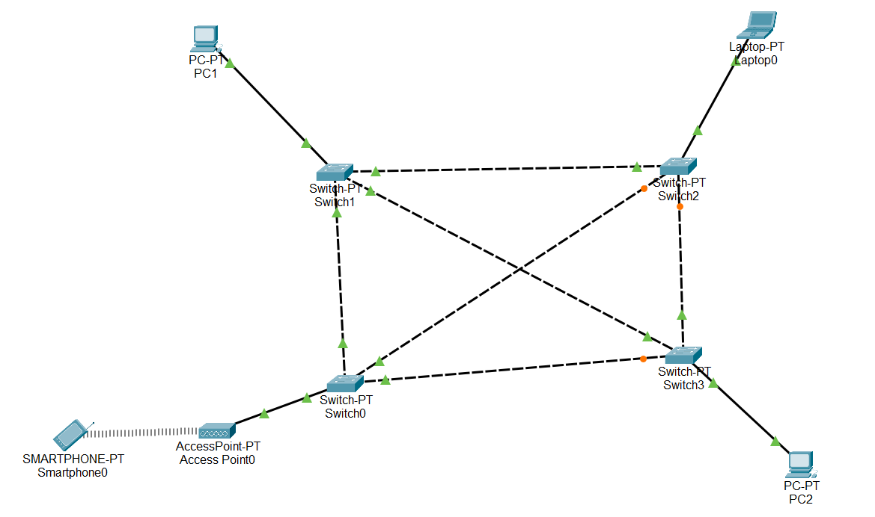Mesh Topology:
2. Hybrid Topology:

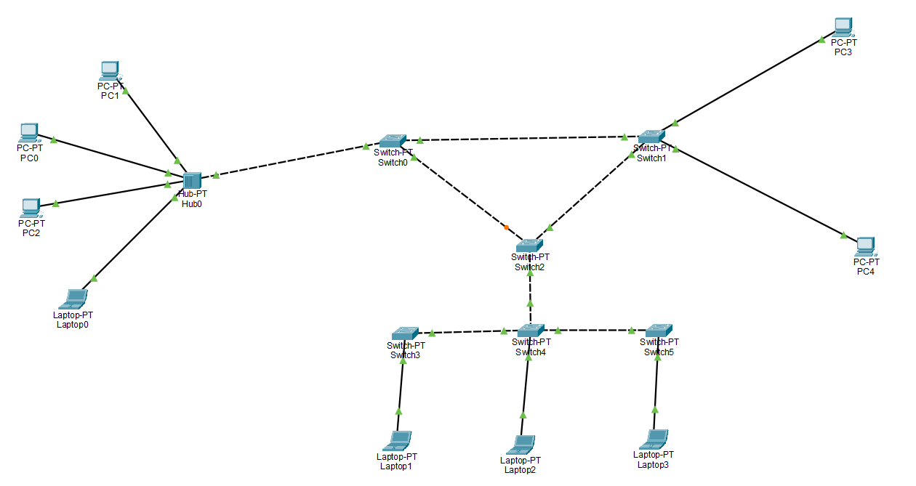

**Assignment 7: VLAN Creation and implementation**

* 1. Take 3 switches and 3 devices for each switch
  2. Connect them through wire
  3. Assign IP addresses to all the end devices
  4. Open CLI of switch and write command to create and manage VLAN

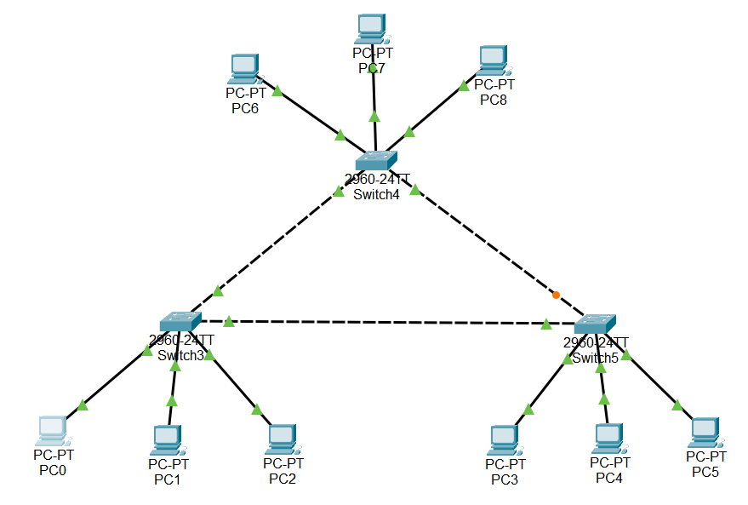

vlan 10

name V10

vlan 11

name V11

vlan 12

name V12

int fa 0/1

sw mo ac

sw ac vlan 10

ex

int fa 0/2

sw ac vlan 11

ex

int fa 0/3

sw ac vlan 12

ex

int fa 0/4

sw mo tr

sw non

ex

int fa 0/4

sw mo tr

sw non

ex

Output:

